December 1, 2012

Mr. Dana H. Grant  
73 Barley Mill Crescent  
Bowmanville, ON L1C 4E9

Dear Mr. Grant,

Thank you for your recent letter. The environment is an important topic for students to be aware of and interested in. As Minister of the Environment, one of my duties is to liaise with teachers and students and to encourage investigation into environmental issues.

We are facing an environmental crisis and need a fresh perspective and advice. Canada’s natural resources are being used at unsustainable rates and a crisis is looming.

If we wish to maintain our current standard of living, we need to find ways to conserve these resources. The Prime Minister has empowered me to seek the assistance of your grade 5 students to help find a solution.

I hereby authorize you to direct your students to research the issues you referenced in your letter: Energy, air, water, fossil fuels and recycling. Through their investigations, students shall become experts on their assigned topic.

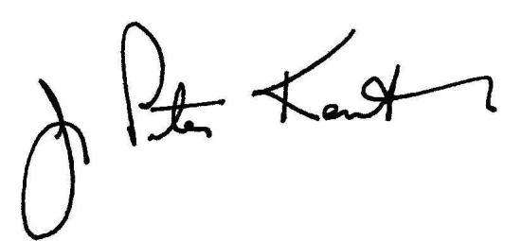Please forward a summary of your students’ findings at your earliest convenience. I will review and share them with the Prime Minister at the upcoming Environmental Impact Convention.

Sincerely,



The Honourable Peter Kent, P.C., M.P.

c.c.: The Honourable James M. Flaherty, P.C., M.P.